## Part 1: Multiprocessed Programming (myshell.c)

Screenshot #1: quit



Screenshot #2: /bin/ls (return list of files in directory)



Screenshot #3: /bin/ls -alF (return long formatted list of files in directory)

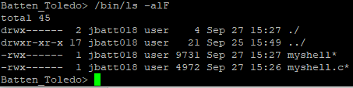

Screenshot #4: /bin/grep hello myfile.txt will look through the myfile.txt for “hello” and print the line where it is found



Screenshot #5: /bin/ls ; /bin/cat myfile.txt will print the files in the directory and also print the contents of myfile.txt

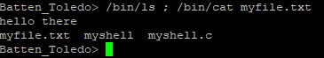

Screenshot #6: /bin/sleep 100 & will sleep for 100 seconds in the background. When we /bin/ps to see all processes running, you can see sleep is still executing. When you exit, the shell will wait for the process to finish (meaning it will wait until it has slept for a total of 100 seconds).

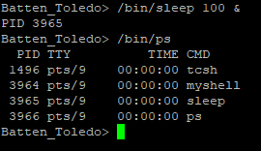

Screenshot #7: /bin/ls -l ; /bin/sleep 10 &; /bin/sleep 100 &; /bin/cat myfile.txt will list all files in the directory in long format, will sleep for 10 seconds in the background, will sleep for 100 seconds in the background, and print the contents of myfile.txt. When you do /bin/ps, you can see that both sleep processes are running in the background.

